MuleSoft Anypoint Platform
Experiment 2

Aim:
Create Mule Project to display the student details with the following fields
SNo, Name, Age, CGPA, address (HNo, Street, District, State)
Solution:
Steps:
- The Package Explorer in Anypoint Studio provides a structured view of all Mule projects in your workspace. It displays folders, files, configurations, and dependencies for easy navigation and management. Developers use it to organize resources, access flows, and manage project settings efficiently.
- 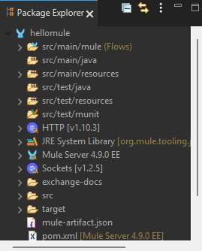
- Navigate to Open Anypoint Studio and define your workspace.
- Go to File ➜ New ➜ Mule Project.
- Enter Project Name: HelloMule, then click Finish.
- 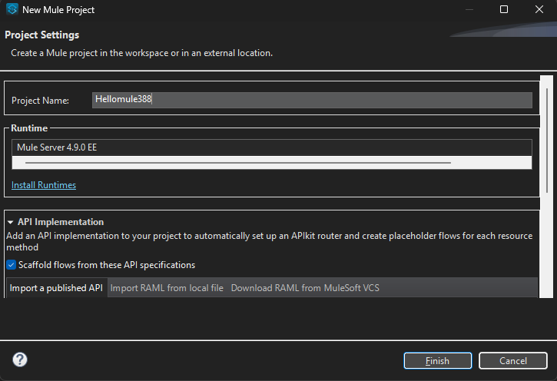

- Design the Flow:
  - 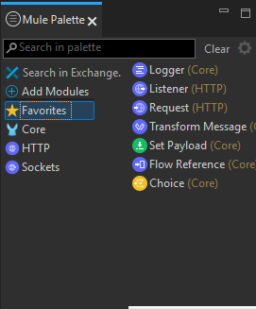
  - The Mule Palette in Anypoint Studio provides a collection of components and modules that can be used to build Mule applications.
It allows developers to drag and drop processors like HTTP, Database, Core, and more onto the flow canvas.The palette is organized by module types and includes a Favorites section for quick access to commonly used components.
  - Logger (Core): Logs custom messages or variables to the console during flow execution.
  - Listener (HTTP): Listens for incoming HTTP requests at a configured path and port.
  - Request (HTTP): Sends HTTP requests to external APIs or services.
  - Transform Message (Core): Transforms input payload into a desired format using DataWeave.
  - Set Payload (Core): Sets or overrides the current message payload with a static or dynamic value.
  - Flow Reference (Core): Invokes another flow within the same Mule application.
  - Choice (Core): Adds conditional logic to route messages based on specified expressions.

  - Add HTTP Listener :
    - Open the HTTP module.
    - Drag HTTP Listener onto the canvas
    - 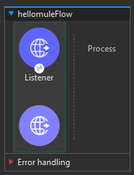
  - Configure HTTP Listener:
    - Click the component; in Properties, click + to add a global configuration:
      - Host: 0.0.0.0 and give port as 8081
      - 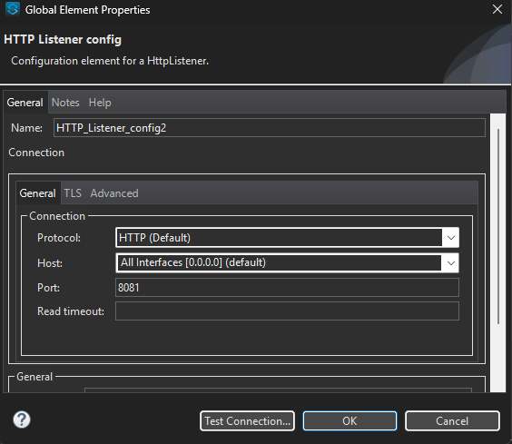
      - Under General, set Path: /student
      - 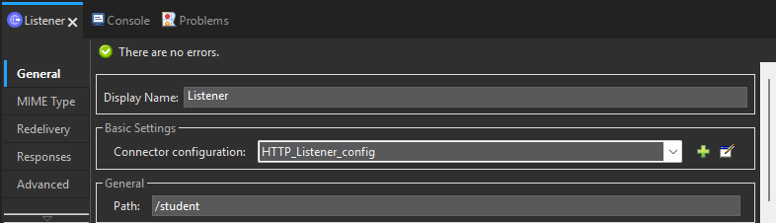

  - Add Transform Message
    - 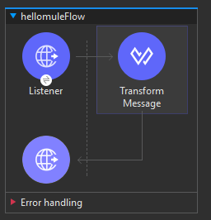
    - In the Properties panel, near the output payload remove the java in the second line and keep json and then add a message in it.
      - 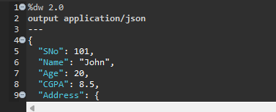
  - Save the files.
  - Right-click on the canvas ➜ Run project 'HelloMule'.
  - Monitor the Console until you see “DEPLOYED” .
  - Go to your browser and then type this web address: “localhost:8081/student”

  - You should see a output like this.
  - 